Dry Bath Incubator——ES2000
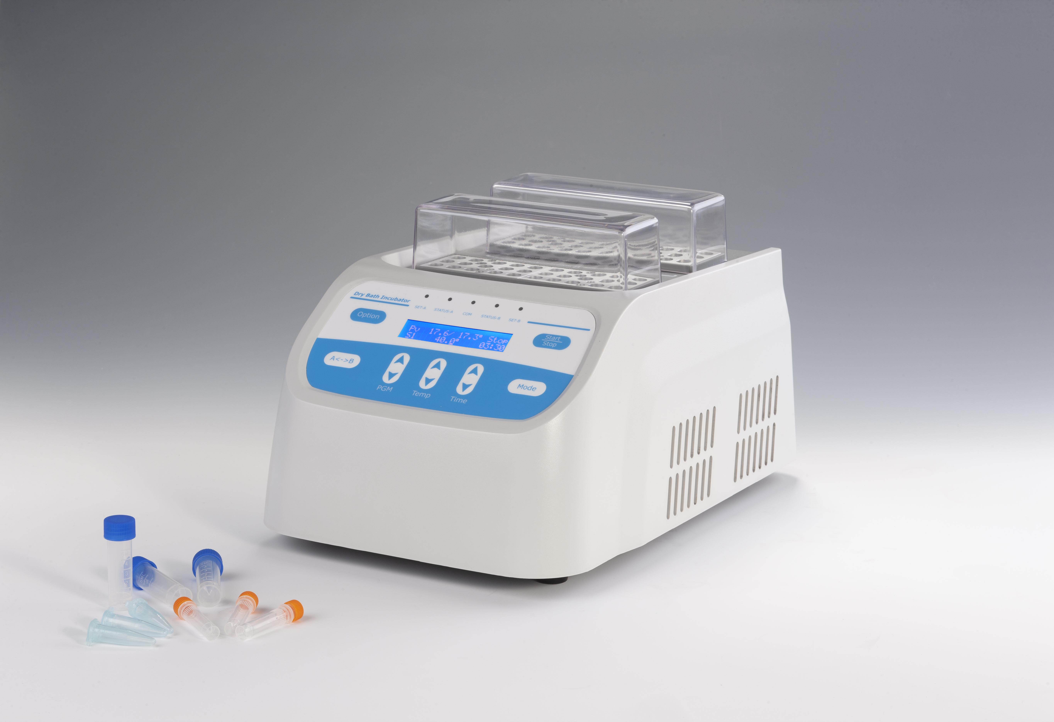
Description:
ES2000 Dry Bath Incubator is a microprocessor-controlled dry block heating system with highly precise temperature control, making it an alternative to the traditional water bath devices. Timing flexible, constant temperature function and two-group independent temperature control mode are effectively improving the efficiency of the laboratory work. It is the ideal equipment, applying to kinds of sample incubation, catalyze, save and etc.

Features:
- LCD display, simple interface. Easy to set up and use.
- Accurate temperature control, high stability.
- Unique two-group(A/B) temperature control realizes running independently
or simultaneously.
- One operation interface can realize two-group temperature and timing
setting independently or simultaneously.
- Different kinds of aluminum blocks are available. Block can be customized.
- Automatic preheating function.
- Auto resume to run after power failure.
- Automatic running function.
- Built-in temperature calibration function.
- Built-in over-heating protection device, safe and reliable.

Parameters:
Model | ES2000
Temp setting range | 0°C ~100°C
Temp control range | RT+5°C ~100°C
Timing range | 1min ~ 99h59min/∞
Temp accuracy | ≤±0.3°C*@37°C
Display accuracy | 0.1°C
Temp uniformity | ≤±0.3°C@37°C *
Heating time | ≤15min(from 25°C~100°C)
Auto heating | Yes
Auto running | Yes
Auto resume to run | Yes
Temperature control group | 2
Block quantity | 4
Power | 240W
Voltage | AC110V or AC220V/50-60Hz
Fuse | 250V 3A Ф5×20
Dimension(mm) | 370x254x217
Weight(kg) | 5.0

Optional Blocks:
Model | Capacity | Model | Capacity
MiniBoxA | 15x2.0ml centrifuge tube | MD40 | 15xΦ10mm
MiniBoxB | 15x1.5ml centrifuge tube | MD41 | 12xΦ12mm
MiniBoxC | 24x0.5ml centrifuge tube | MD42 | 8xΦ15mm
MiniBoxD | 32x0.2ml centrifuge tube | MD43 | 8xΦ16mm

